|  |
| --- |
| **CME2203 Lab 3 Pre-lab**  **Name-Surname:**  **Student Number:**  **Section:**  **Subject:** Superposition Principle |

(updated: 09/11/2022)

**Pre-lab Procedure** 

➔ Each student must prepare the pre-lab and upload it **INDIVIDUALLY**!

➔ Upload as a **.PDF** file.

➔ Draw the schematic for the circuit in Figure 1 using LTSpice. Remember to put a **text label** in the following format:

2022-23 Fall

CME2203, LAB3

*Name Surname, Student No*

*Section*

1. Upload a **PDF** file including your circuit design and simulation results visible (see example in Figure 1)

**2022-2023 Fall**

**5V**

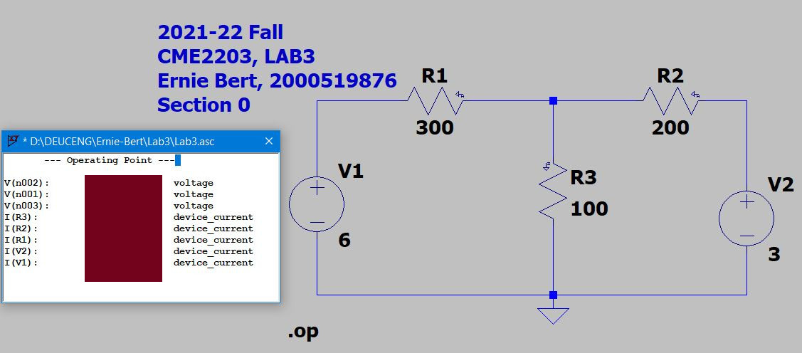

Figure 1 – Circuit Design in LtSpice

1. Note the simulation results and make the theoretical calculations using the superposition principle. You can use the tables given below. Compare the values and check if they are consistent.

**Simulation Results from LTSpice**

|  |  |  |
| --- | --- | --- |
| Circuit Element | I (mA) | V (V) |
| R1 | I(R1)= | n1-n2= |
| R2 | I(R2)= | n2-n3= |
| R3 | I(R3)= | n2= |

Fill the table below with your calculations. Add as many pages as necessary **to show your calculations to fill in the table below.**

|  |  |  |  |  |  |  |  |
| --- | --- | --- | --- | --- | --- | --- | --- |
|  |  | R1 | | R2 | | R3 | |
| 3V | 5V | I1 (mA) | VR1 (V) | I2 (mA) | VR2 (V) | I3 (mA) | VR3 (V) |
| |  | | --- | | ✓  | | - |  |  |  |  |  |  |
| - | ✓ |  |  |  |  |  |  |
| Total | |  |  |  |  |  |  |

**!!!No LATE submissions!!!Cheating will not be tolerated!!!**

**Good Luck...**

**Calculations Below:**